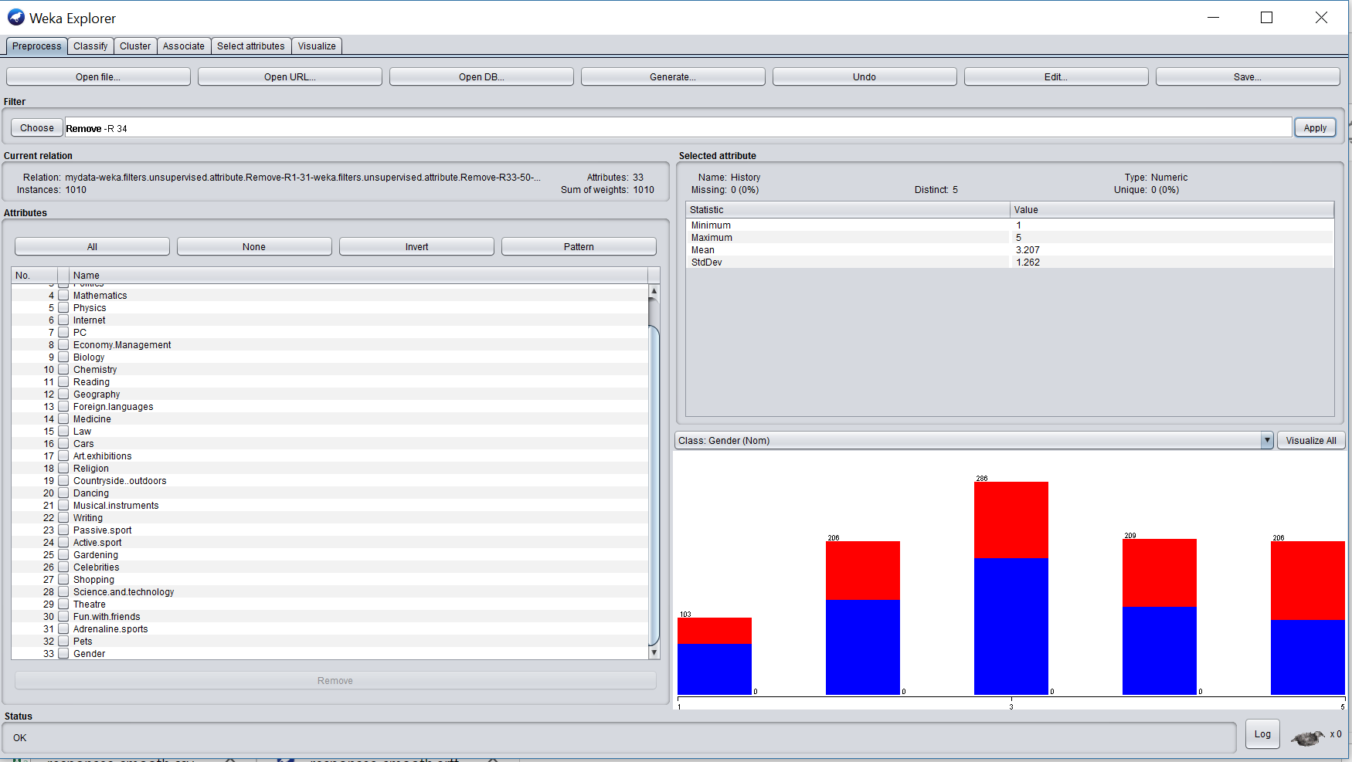

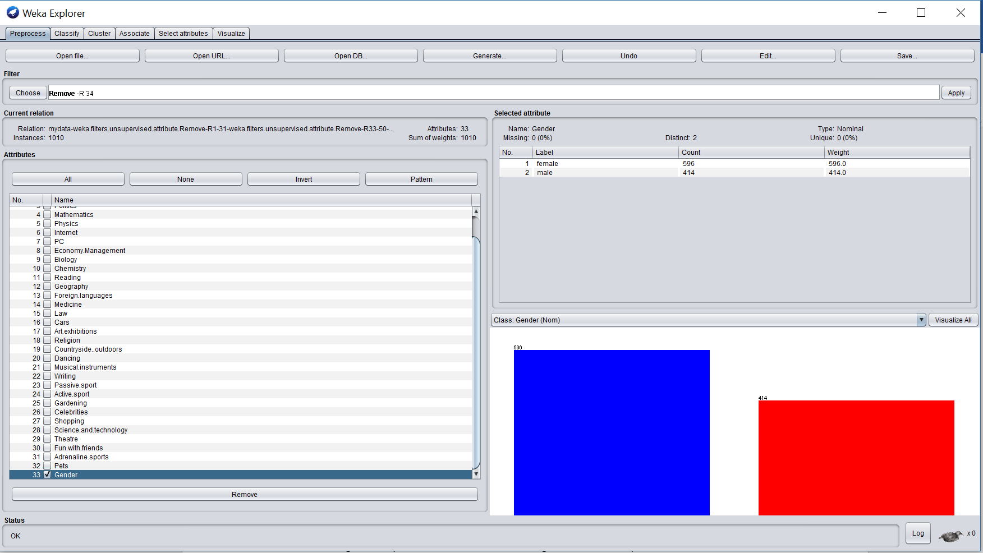

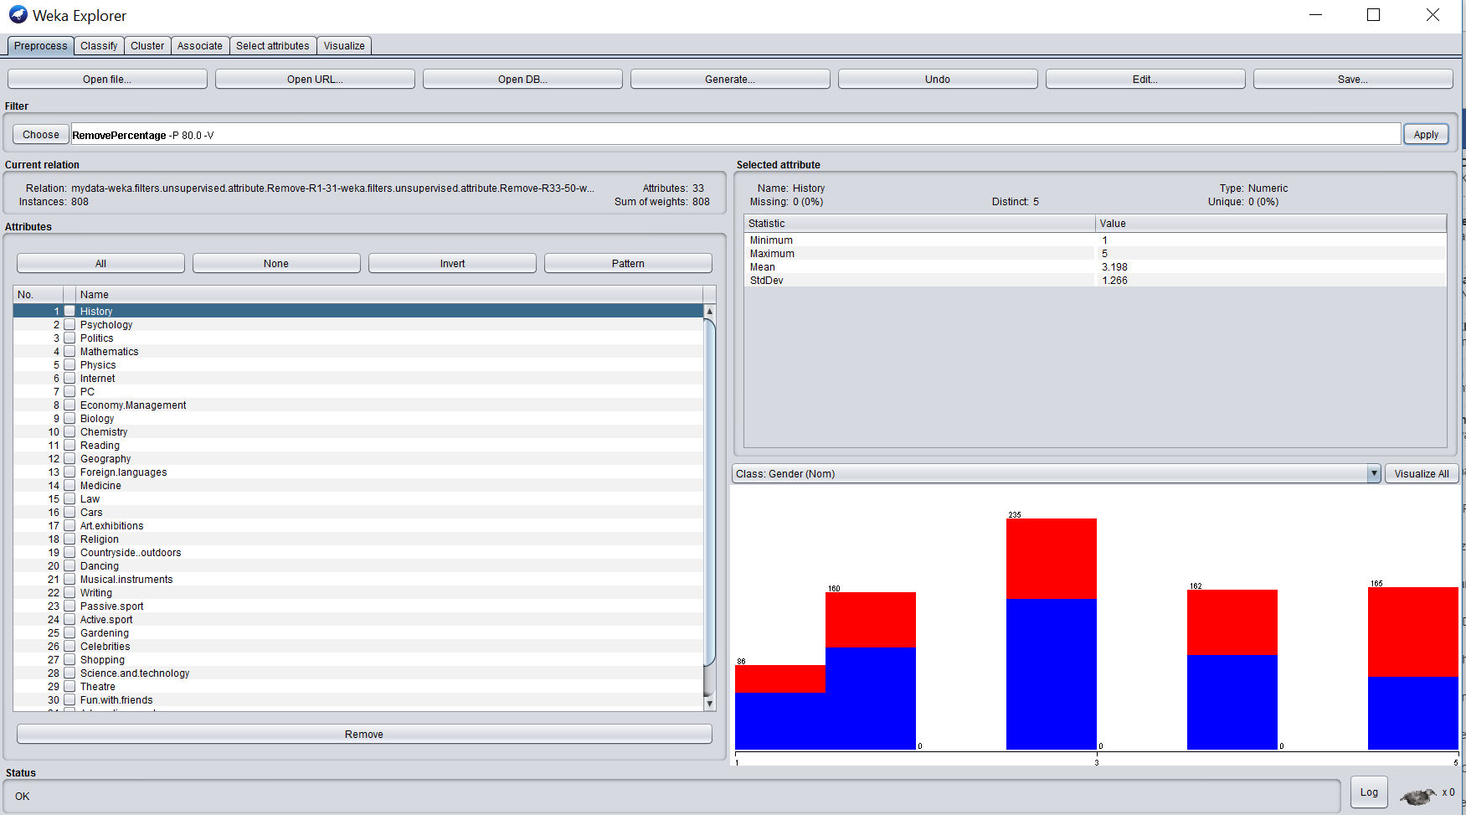

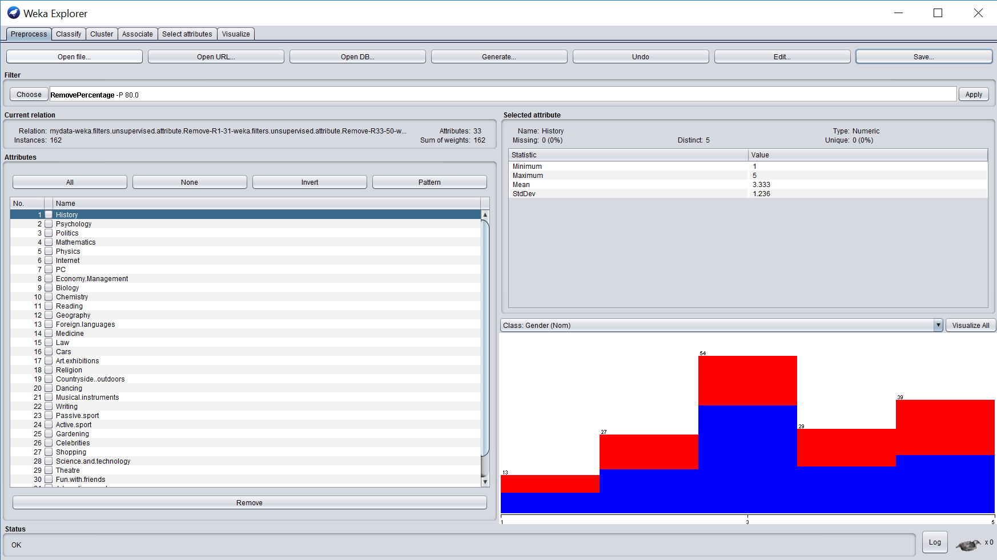

**In NaiveBayes we got accuracy = 85.14%**

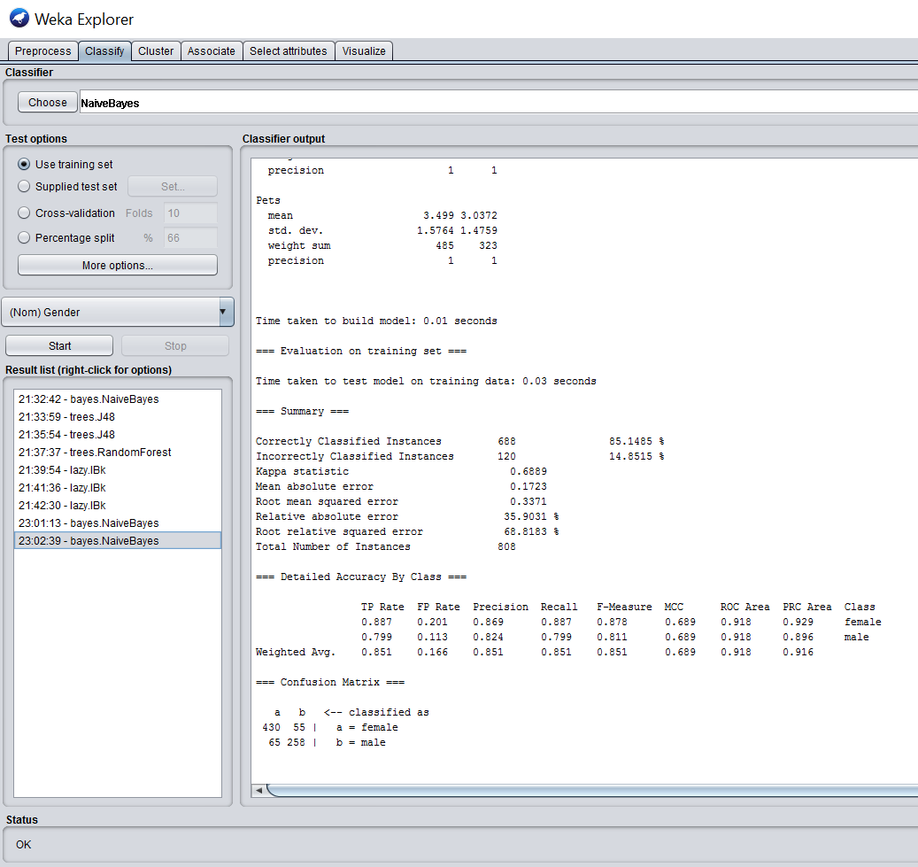

**In J48 decision tree with confidence factor 0.25 we get 95.79% accuracy (Please refer to the below screenshot) :**

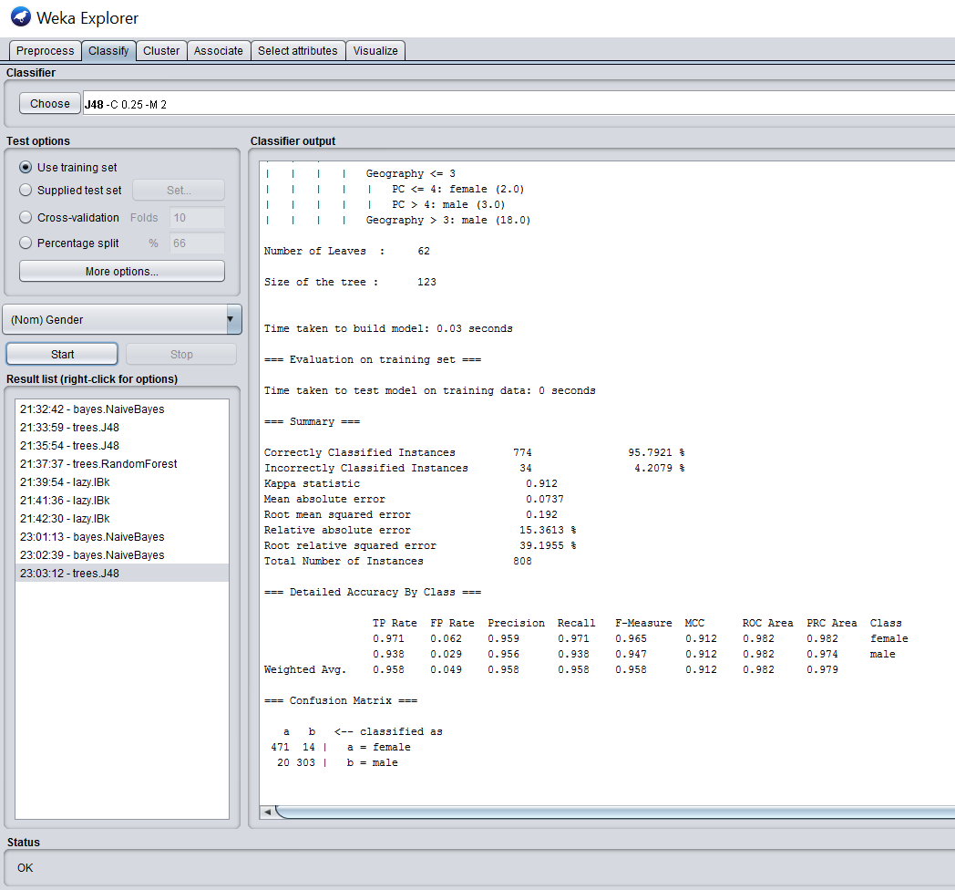

**In J48 decision tree with confidence factor 0.5 we get 96.90% accuracy (Please refer to the below screenshot) :**

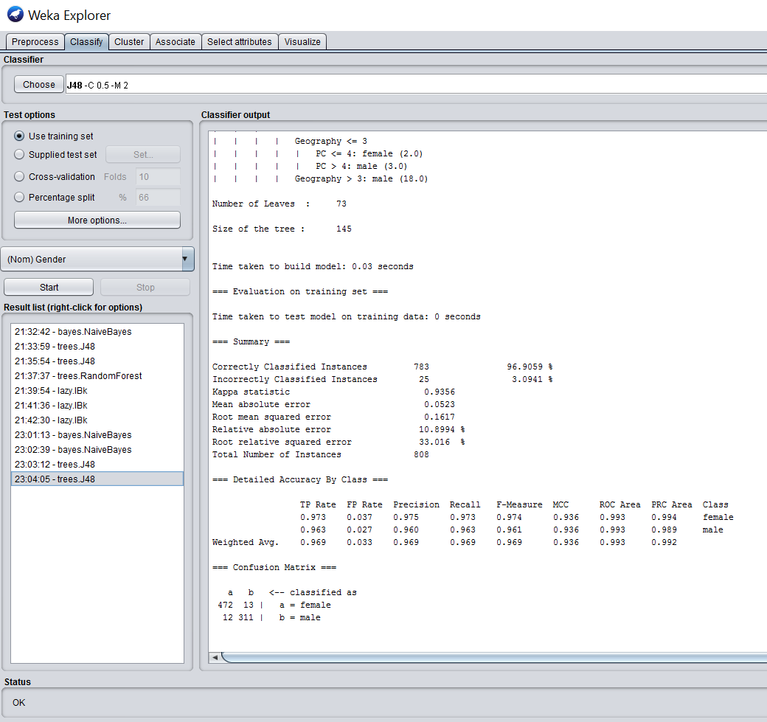

**In randomforest decision tree we get 100% accuracy (Please refer to the below screenshot) :**

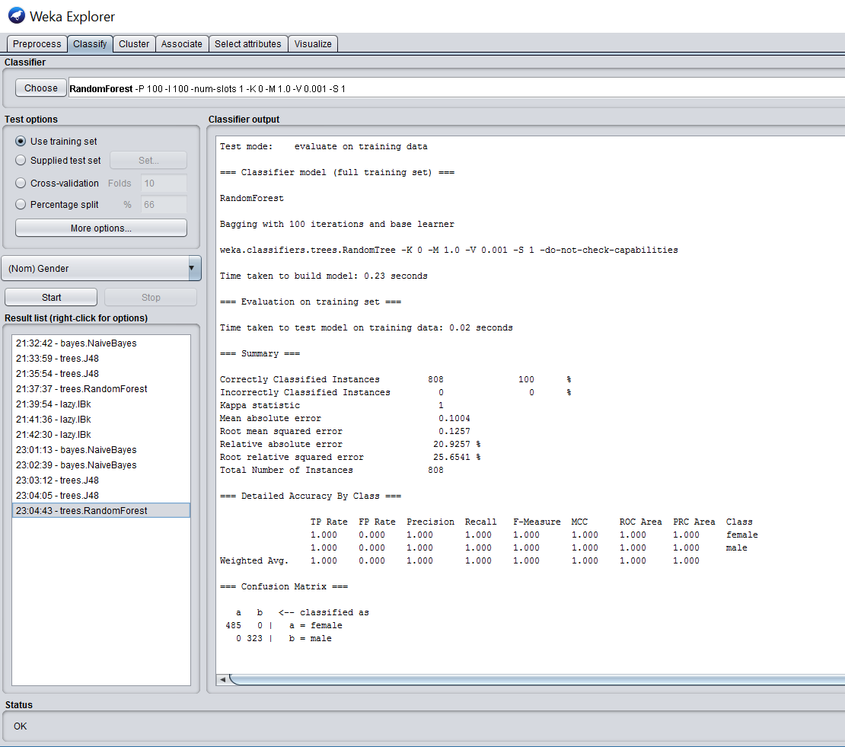

**In Key nearest neighbors with key = 1 we get 100% accuracy.**

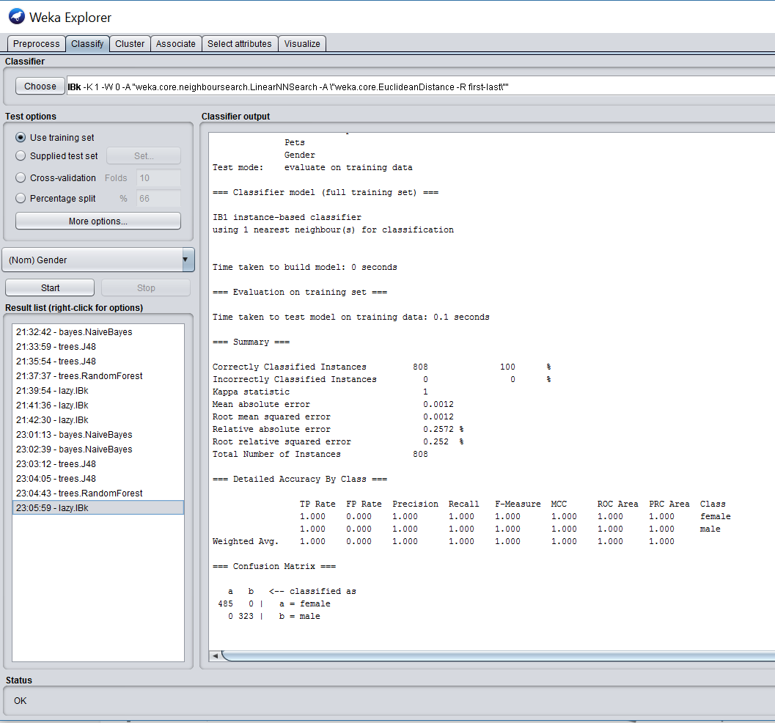

**In Key nearest neighbors with key = 3 we get 100% accuracy.**

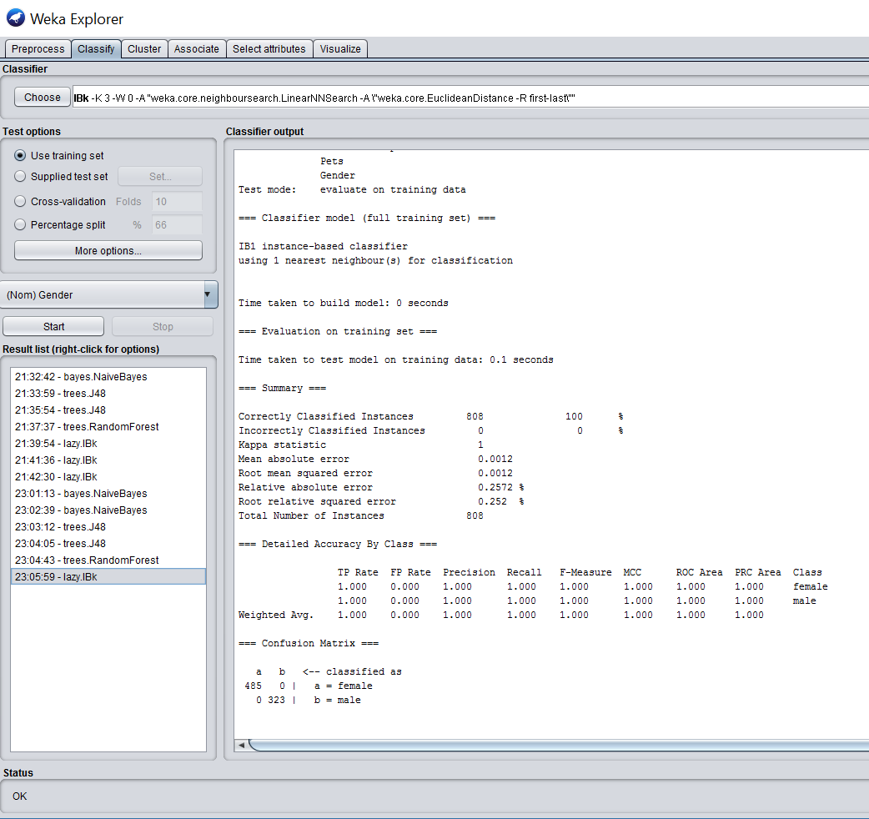

**In Key nearest neighbors with key = 5 we get 90.09% accuracy.**

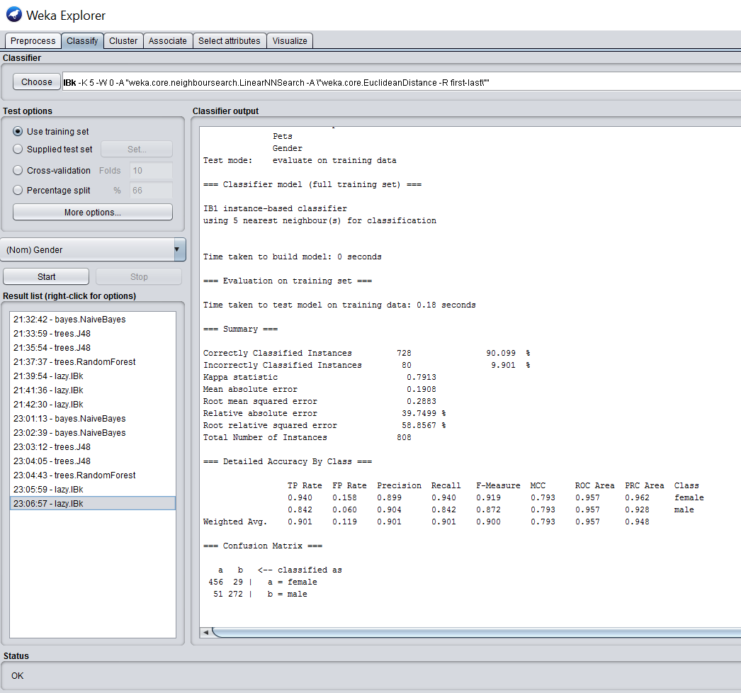

**In NaiveBayes we got accuracy = 84.56% over interest_test**

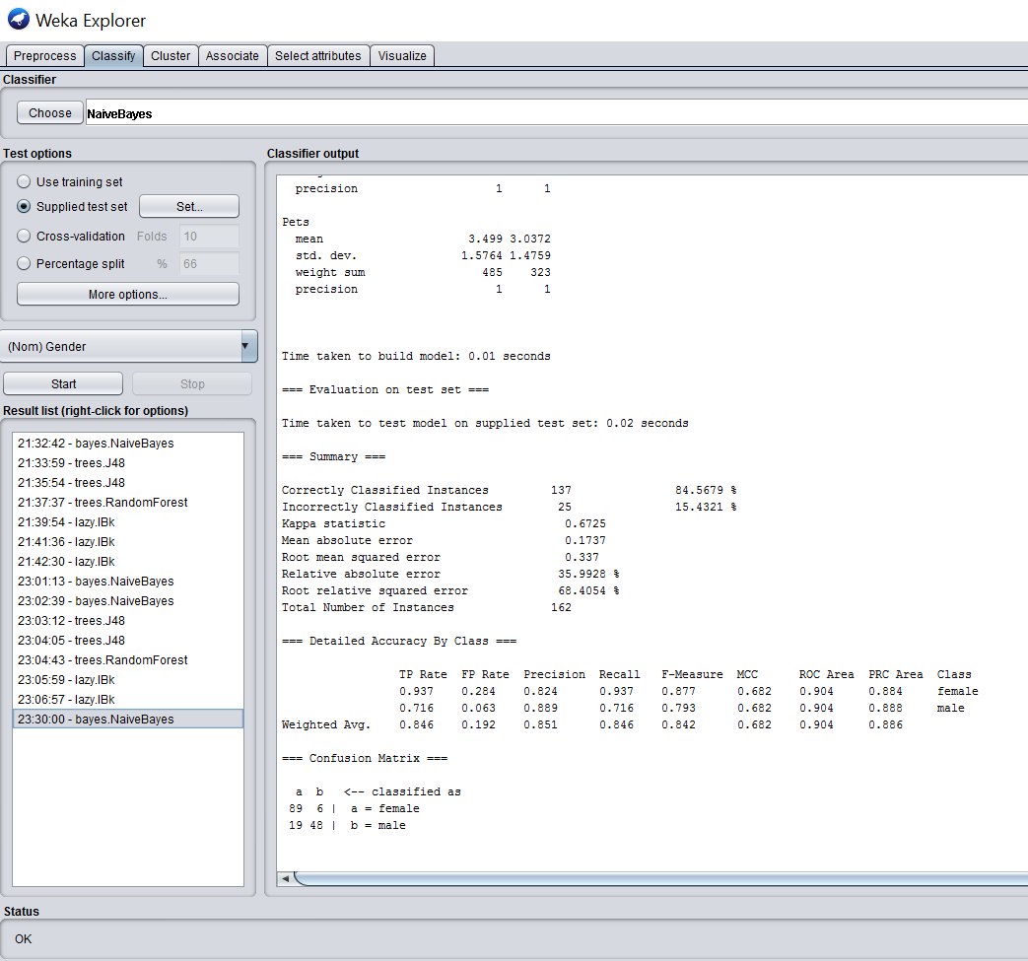

**In J48 decision tree with confidence factor 0.25 we get 95.67% accuracy over Interest_test data set(Please refer to the below screenshot) :**

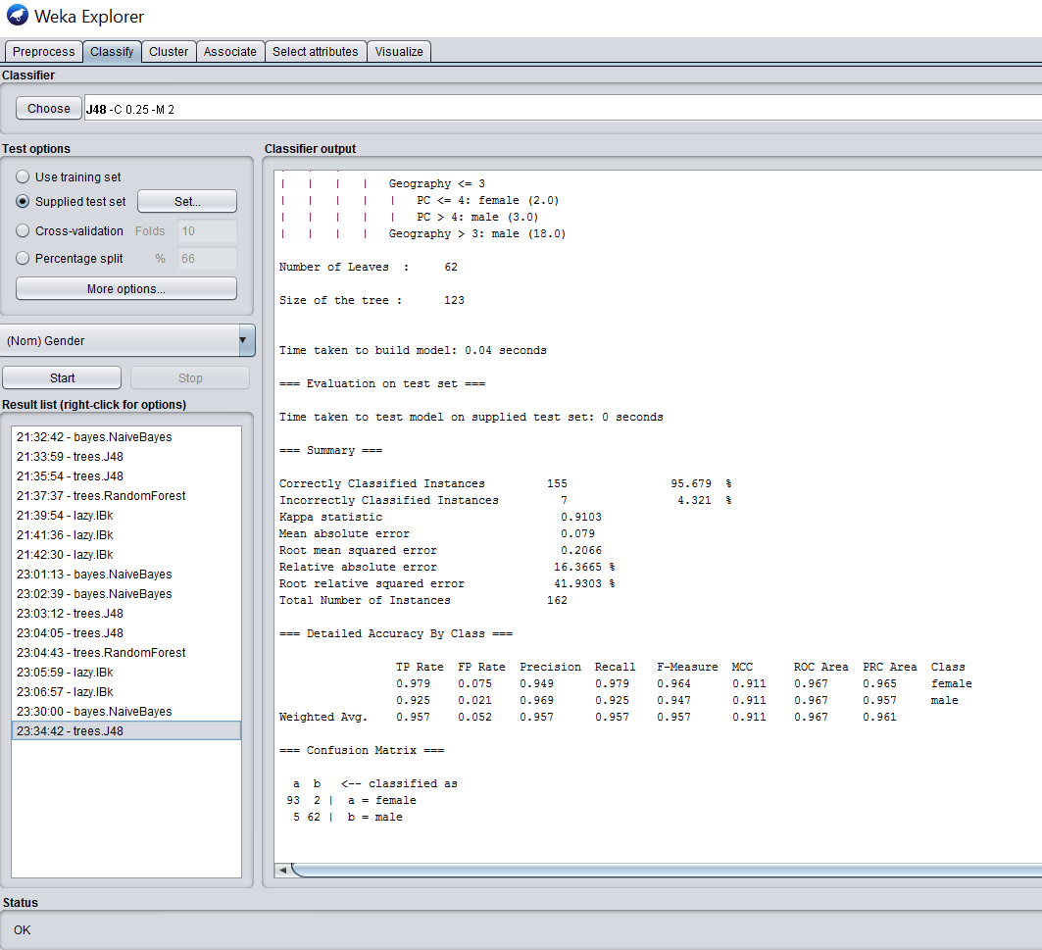

**In J48 decision tree with confidence factor 0.5 we get 96.91% accuracy over Interest_test data set(Please refer to the below screenshot) :**

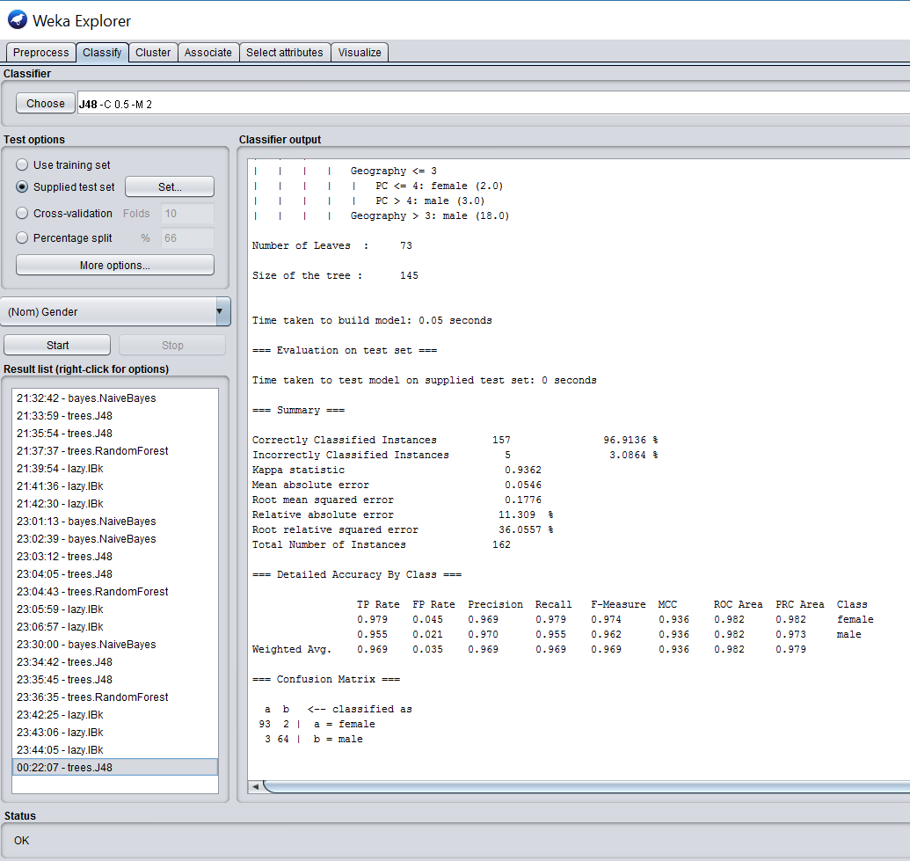

**In randomforest decision tree we get 100% accuracy over Interest_test data set (Please refer to the below screenshot) :**

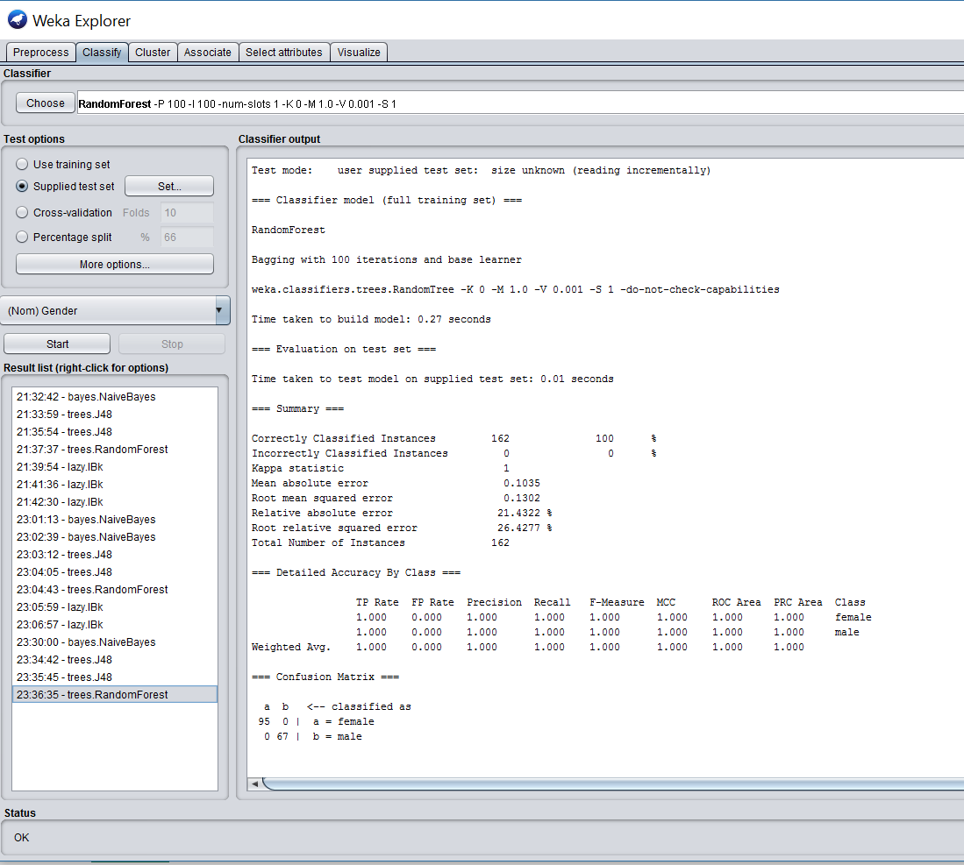

**In Key nearest neighbors with key = 1 we get 100% accuracy on Intrest_test dataset.**

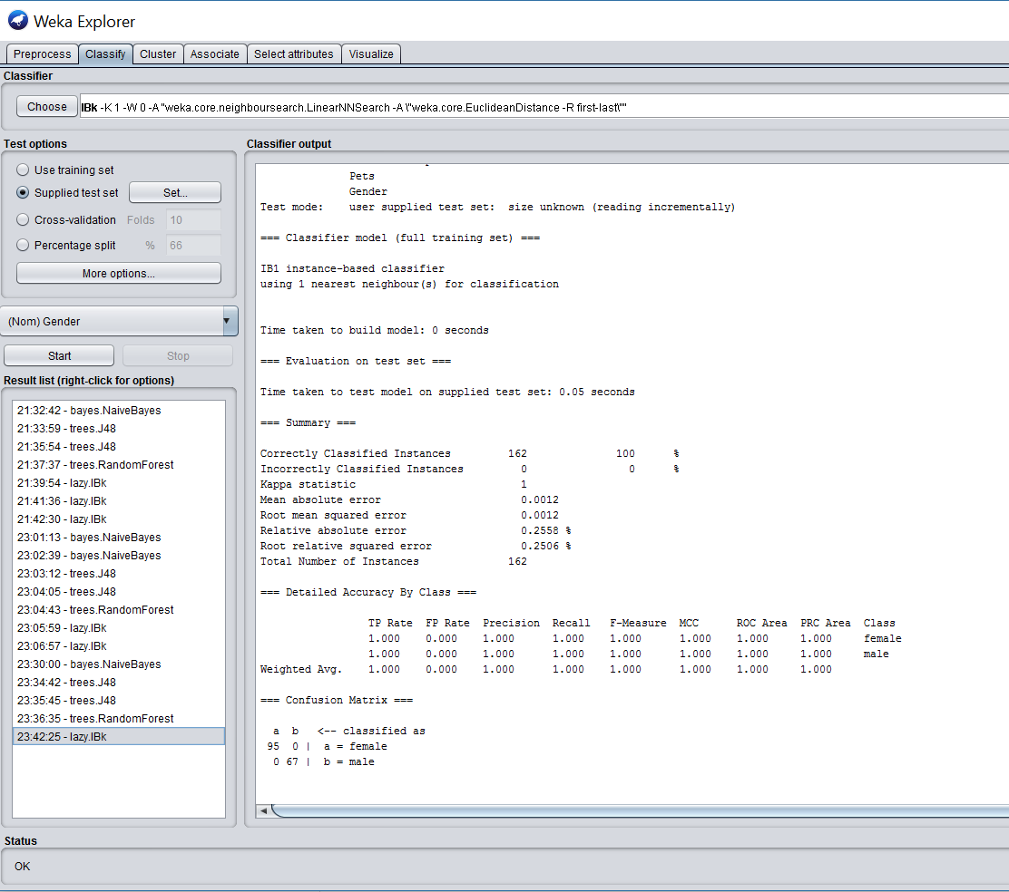

**In Key nearest neighbors with key = 3 we get 92.59% accuracy on Intrest_test dataset.**

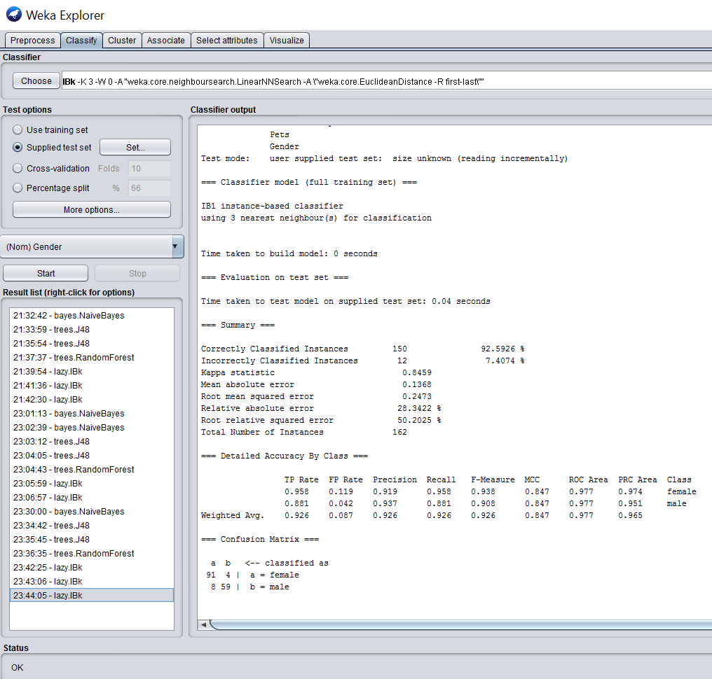

**In Key nearest neighbors with key = 5 we get 93.20% accuracy on Intrest_test dataset.**

